SOMERSAULT

May 2017

Vol 40, No 3

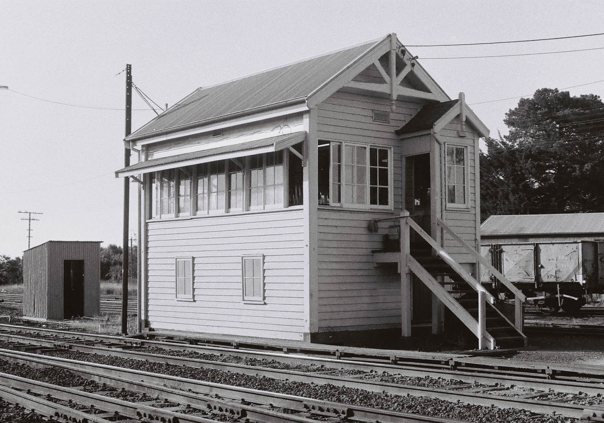Signalling Record Society of Victoria

# Society Contact Information

(Front cover) Woodend, situated near the crest of the Great Dividing Range, was a busy place for most of its line. Up and Down sidings were provided to allow shorter trains climbing the divide to be remarshalled into longer trains descending the other side. To control this work, Woodend signal box was opened in June 1891. With the move to block freight trains, the sidings at Woodend were lifted and it was planned to make the station staff responsible for signalling. To this end, Rupertswood was closed as a block post and the signal levers there relocated to the Up platform at Woodend. Unfortunately, the signals at Woodend were too far out to be worked from non-interlocked levers. Macedon was then closed as a block post to allow the B pattern frame there to be relocated to a new signal bay at Woodend. This finally allowed the signal box to be closed on 14 March 1995. Photo David Langley

Published by the Signalling Record Society Victoria Inc (A0024029F)

EDITOR: Andrew Waugh, 28 Amelia St McKinnon, VIC, 3204  
Phone (03) 9578 2867 (AH), (03) 9348 5724 (BH), email andrew.waugh@gmail.com

PRESIDENT: David Langley, P.O. Box 8, Avenel, VIC, 3664, Phone (03) 5796 2337

SECRETARY and MEMBERSHIP OFFICER: Glenn Cumming,  
Unit 1/4-6 Keogh St, Burwood, VIC 3125. Phone (03) 9808 0649 (AH)

NSW CONTACT: Bob Taaffe, 63 Hillcrest Rd, Tolmans Hill, TAS, 7007, Phone: (03) 6223 1626

QUEENSLAND CONTACT: Phil Barker  
PO Box 326, Samford, QLD, 4520, Phone: (07) 3289 7177, email: signal-1@bigpond.com

Unless articles use copyrighted information, articles may be reprinted without prior permission but acknowledgment is required. Opinions expressed in articles appearing in SOMERSAULT or supplements are not necessarily those of the S.R.S.V. (Inc.)

# Minutes of Meeting held Friday 17 March 2017, At the Surrey Hills Neighbourhood Centre, 1 Bedford Avenue, Surrey Hills, Victoria.

Present: – Wilfrid Brook, Glenn Cumming, Graeme Dunn, Ray Gomerski, Chris Gordon, Judy Gordon, Bill Johnston, David Jones, David Langley, Andrew McLean, Phillip Miller, Colin Rutledge, Rod Smith, David Stosser and Rob Weiss.

Apologies: – Jon Churchward, Keith Lambert, Laurie Savage, Peter Silva, Andrew Waugh and Andrew Wheatland.

Apologies: – David Langberg.

The President, Mr. David Langley, took the chair & opened the meeting at 21:11 hours, following the 2017 Annual General Meeting.

Minutes of the November 2016 Meeting: – Accepted as read. Phillip Miller / Bill Johnston. Carried.

Minutes of the February 2017 Meeting: – Accepted as read. Phillip Miller / Bill Johnston. Carried.

Business Arising: – Nil.

Correspondence: – Invoice from Surrey Hills Neighbourhood Centre for hire of meeting room for 2017.

Payment sent to Surrey Hills Neighbourhood Centre for hire of meeting room for 2017.

Letter to Box Hill Miniature Steam Railway Society thanking them for hosting the November 2016 meeting. Phillip Miller / Wilfrid Brook. Carried.

Reports: – Nil.

General Business: – Bill Johnston described the new works at Bayswater and Blackburn.

Phillip Miller described the new railway stations at Bentleigh and McKinnon.

Phillip Miller described the proposed works on the Frankston Line recently announced by the Level Crossing Removal Authority. The meeting discussed some of the engineering challenges to be overcome (e.g. the water table) and the reasons why some of the level crossings will be replaced by trenches while others will be replaced by flyovers.

The meeting discussed delays for trains in the metropolitan area when passing Automatic Signals at the stop position. It was noted that delays are being made worse because of the requirement for Drivers to telephone and listen to a recorded message before tripping past an Automatic Signal.

David Stosser discussed the recent article in “The Age” newspaper about the double line block working on the Seymour Line and noted the lack of Starting Signal control. It was advised that Starting Signal control had not been used with Winter’s Block Instruments in Victoria while noting that additional contacts were provided in the instruments for that purpose.

Meeting closed at 22:02 hours.

The next meeting will be on Friday 19 May, 2017 at the Surrey Hills Neighbourhood Centre, Bedford Avenue, Surrey Hill, commencing at 20:00 hours (8.00pm).

# Signalling Alterations

The following alterations were published in WN 5/17 to WN 16/17, and ETRB A circulars. The alterations have been edited to conserve space. Dates in parenthesis are the dates of publication, which may not be the date of the alterations.

13.02.2017 Hawthorn - Auburn (SW 32/17, WN 5)

On Monday, 13.2., the existing 25Hz 2.2KV signalling power supply between Hawthorn and Auburn was upgraded to 50Hz. Kingfisher units were provided at locations 179ZB, 197ZB, 230ZB, and 260ZB to provide indications for the tracks between Hawthorn and Auburn. The existing PLC system was decommissioned.

13.02.2017 Glenferrie (SW 32/17, SWP 3/17, WN 5 & 13)

On Monday, 13.2., a disaster recovery site for Camberwell signal box was commissioned at Glenferrie. An emergency signal control panel, Sigview screens and servers, a kingfisher unit, and telephone communications were installed. A 5P key switch was provided for switching over control.

A new clause f was added to Burnley Group Operating Procedure 4 (Camberwell – Failure of Signals”).

The 5P keyswitch at Glenferrie has a yellow LED labelled “IXL Link Alive”. When lit, this LED indicates that the communications link between the Sigview at Glenferrie and the CBI is operational. Before attempting to transfer control to Glenferrie, this LED must be lit.

To take control, a 5P keyswitch must be inserted and turned to the Local (R) position. The red ‘Local’ LED will flash while control is being established. The LED will be lit when the Sigview panel has control. To relinquish control, the keyswitch must be turned to the ‘Remote (N)’ position. The remote LED will flash as control is transferred.

13.02.2017 Huntingdale – Clayton (SW 433/16, WN 1)

On Friday, 6.1., the pedestrian crossing on the Up side of Clayton Road was reopened.

14.02.2017 Selby (A 4/17)

On Tuesday, 14.2., a red crossing protection indication was commissioned at Long Pockitt Lane. When illuminated it indicates that the crossing has timed out due to a failure in the approach track circuitry and that the boom barriers will only begin to operate when the locomotive enters the island track circuit covering the roadway area.

Due to poor visibility on the Up approach to the level crossing an additional Up indicator was commissioned to repeat both the crossing protection signal and the red crossing protection indicator. The additional indicator is located on a mast 30 metres in the Down direction from the level crossing.

20.02.2017 Yarraville (SW 46/17, WN 7)

On Monday, 20.1., the trap track circuit was removed from Anderson Rd. SW 61/16 was cancelled.

21.02.2017 Spotswood (SW 47/17, WN 7)

On Tuesday, 21.1., the trap track circuit was removed from Hudson Rd. SW 62/16 was cancelled.

22.02.2017 Newport (SW 50/17, WN 8)

On Wednesday, 22.2., Points 608U was provided with an M23A dual control point machine. The selector lever will be secured by a signal maintenance padlock. Amend Diagram 13/15 (Newport)

28.02.2017 Colac – Camperdown (SW 27/17, WN 9)

On Tuesday, 28.2., boom barriers were provided at the existing passive crossing at Back Larpent Road (158.478 km). Operation of the level crossing will be by axle counters. Healthy state indicators and yellow whistle boards will be provided. Remote monitoring equipment will be provided. There will be no local axle counter reset functions available, and on or off tracking of road rail vehicles will not be permitted until further notice. Amend Diagram 118/14 (Birregurra – Colac).

28.02.2017 Lal Lal (TON 17/17, WN 10)

On Tuesday, 28.2., Track Machines were prohibited from using the siding (133.890 km – 134.950 km) due to poor sleeper condition. The siding remains booked out (TON 192/08)

01.03.2017 Clayton (SW 38/17 & 58/17, WN 7 & 10)

On Wednesday, 1.3., the Down side pedestrian crossing at Clayton Rd was reopened. The automated pedestrian gates were not restored to use. The gates are expected to be restored to service by Saturday, 11.3.

06.03.2017 Flinders St (SW 67/17, WN 10)

On Monday, 6.3., Home 156 (No 1A Track) was upgraded to LED heads.

06.03.2017 Jeparit (TON 19/17, WN 11)

On Monday, 6.3., the Down end main line points (398.875 km) were booked out due to poor timber condition. Access to the siding is still available by the Up end points.

(07.03.2017) Caulfield – Murrumbeena (SW 64/17, WN 10)

The pedestrian crossings at Cosy Gum Rd and Blackwood St have been permanently closed to public access. However, the crossings will continue to be used by construction workers and the pedestrian gates at Blackwood St remain active. The pedestrian gates at Cosy Gum Rd will be reactivated as from Friday, 3.3.

07.03.2017 Flinders St (SW 68/17, WN 10)

On Tuesday, 7.3., Homes 316 & 316P (Platform 2) were upgraded to LED heads.

08.03.2017 Flinders St (SW 69/17, WN 10)

On Wednesday, 8.3., Home 318 (No 2 East Track) was upgraded to LED heads.

09.03.2017 Flinders St (SW 70/17, WN 10)

On Thursday, 9.3., Home 315 (No 2 East Track) was upgraded to LED heads.

13.03.2017 Protective Local Signal Blocking (SW 30/17, WN 11)

As from 0001 hours on Monday, 13.3., Protective Local Signal Blocking (PLSB) can be used to protect signal maintenance at Wallan, Kilmore East, Broadford, and Seymour. PLSB can only be used where the work will not affect the track, create an obstruction, or require the use of any machinery within three metres of the line. It cannot be used where an Absolute Occupation is in force, where Track Permission has been granted for a road/rail movement, or where a plant train or track machine is to operate. PLSB can only be used within defined station limits (i.e. between the first Home signal and the starting or Home signal leading to the next block section).

13.03.2017 Glenferrie (SWP 3/17, WN 13)

From Monday, 13.2., an emergency signal control panel located in the SMs office at Glenferrie was commissioned. Clause 4F is to be added to Burnley Group Operating Procedure No 4 (Camberwell – Failure of Signals).

A 5P keyswitch is located at the emergency signal control panel. It has a yellow LED labelled ‘IXL Link Alive; and red LEDs labelled ‘Remote’ and ‘Local’. The IXL link alive LED must have a steady yellow light before attempting to switch in the emergency panel. The keyswitch can then be turned to ‘Local’. The red ‘Local’ LED will flash, and then become steady when control has been switched. Turning the keyswitch to ‘Remote’ transfers control back to the main panel in a similar fashion.

13.03.2017 Carnegie (SW 19/17, WN 3)

On Monday, 13.3., the station was reopened for traffic. The alterations in the stopping/express selection were removed.

20.03.2017 Oakleigh (SWP 5/17, WN 13)

On Monday, 20.3., Caulfield Group Operating Procedure 12A (Oakleigh – Operation of No 9 Points) was withdrawn.

(21.03.2017) Brooklyn (SW 32/17, WN 11)

Operating Procedure 20 (Brooklyn) was reissued. The procedure now incorporates Operating Procedure 15A (Sunshine – Brooklyn - Newport), and a requirement to ensure the operation of the ARTC points prior to a movement from the Apex Quarry Siding. SW 4/09 and 78/10 are cancelled.

21.03.2017 Carnegie (SW 60/17 & 81/17, WN 10 & 11)

On Tuesday, 21.3., the Up side pedestrian crossing at Koornang Rd was closed. It is expected to be reopened on Friday, 5.5.2017

30.03.2017 Colac – Camperdown (SW 34/17, WN 13)

On Thursday, 30.3., boom barriers will be provided at the passive level crossing at Wiridgil Lane (191.535 km). The crossing is operated by axle counter equipment. Healthy state indicators, yellow whistle boards, and remote monitoring equipment will be provided. Amend Diagram 30/14 (Camperdown – Terang).

30.03.2017 Frankston (SW 90/17, WN 15)

On Thursday, 30.3., air assistance will be provided on point levers 52 & 61.

31.03.2017 Metro WTT Addenda (SW 91/17, WN 14)

On Friday, 31.3., the Working Timetable System Description (WTT Addenda) was superseded by the ‘WTT Network Configuration’ manual. This consists of eight parts: Governance, System Description, Network Boundaries, Line Description, Line Speeds, Ruling Grade Loads, Metro Rolling Stock, and Third Party Rolling Stock.

(04.04.2017) Book of Rules, Section 2, Rule 5 (Distant Signals) (SW 40/17, WN 14)

Section 5, Rule 2, was re-issued for the defined V/Line Regional Network. Clauses b (Distant and Home Signals on One Post) and e (Repeating Signal for a Distant Signal) will not apply to the V/Line Regional Network.

(04.04.2017) Yatpool – Irymple (SW 38/17, WN 14)

Diagram 16/14 (Yatpool – Irymple) replaced 30/07 as in service.

09.04.2017 Book of Rules, Section 3, Rule 1 (Detention at an Automatic Signal) (SW 39/17 & 93/17, WN 14)

As from 0001 hours on Sunday, 9.4., the Book of Rules, Section 3, Rule 1 has been amended.

The following alterations were made:

* 1b) Automatic Signal still at Stop. The Driver may pass an Automatic signal at Stop after contacting the automated recording system. After passing a signal at Stop, the driver must control the speed of the train at ‘Extreme Caution’. This is defined as a speed that is slow enough to be able to stop the train in half the visible distance, but not exceeding either 25 km/h or the posted track speed.
* 4g) Train Stopped at a Two Position Automatic Signal protecting a Level Crossing. Where an automatic signal protects a level crossing in a Train Order or Train Staff section, the Driver must follow clause 1 before passing the signal at Stop.

Circulars SW 505/02 (Connex), SW 1009/02 (Freight Australia) and SWP 5/02 (National Express) are cancelled.

10.04.2017 Southern Cross (SW 36/17, WN 14)

On Monday, 10.4., the approach timers for the operation of the Low Speed Caution aspect were removed from the following Homes: SST500, SST505, SST507 (but only for moves towards Signal 991), SST508, SST509, SST511, SST513, SST515, SST518, SST522, SST524, SST525, SST526, SST527, SST528, SST529, SST531, SST533, SST534, SST535, SST537, SST538, SST539, SST542, SST547, SST548, SST549, SST550, SST552, SST556, SST558, SST564, SST565, SST566, SST567, SST571, SST573, SST577, SST583, SST584, SST585, SST586, SST589, SST590, & SST593.

Data modification were made to alter the sequence of operation on Points 811 at the down side of Platforms 15 & 16 Southern Cross.

End£

# Letters to the Editor

Bob Taaffe writes:

A project to research the history of electric staff in Australia is in the final stages. To complete the work further details of individual instruments are still required.

Could any member who has collected staff instrument numbers, or has instruments in their collection or care, or who has photographed instruments in their travels please send the following information to Bob Taaffe:

* instrument number
* railway where the sighting occurred
* was the instrument battery or magneto
* date of sighting
* a photo of the front of the instrument would be of immense value.

Also, if any member has a copy of the staff instrument register kept by the VR, SAR or CR could a copy would be greatly appreciated.

All replies can be sent to [rtaaffe9@gmail.com](mailto:rtaaffe9@gmail.com)

Peter Fisher writes:

Apropos of the cover of the January 2017 Somersault featuring a picture of Stratford Junction. The caption does not comment on the signalling arrangement before the bracket home – a circa 1918 diagram (available from <http://www.victorianrailways.net/signaling/completedia/stratjct.html>) has a single arm in top to bottom left to right configuration. It may have added to interest too to note that through goods trains were diverted through Maffra to avoid having to reverse at Sale for a period.

Also re the intriguing article on the 1877 NE accident fusees *were* in use during the very earliest railways in England **circa 1830s** as (makeshift) danger signals: *“a red light emanating from a thin tube terminating in a sharp point that entered the ballast - the light being produced by a sharp blow at the upper end”.* I would imagine that the American practice of brakemen hurling them out of the rear of trains could have interesting consequences translated to Victoria during our fire seasons.

# Flinders St Yard Panels

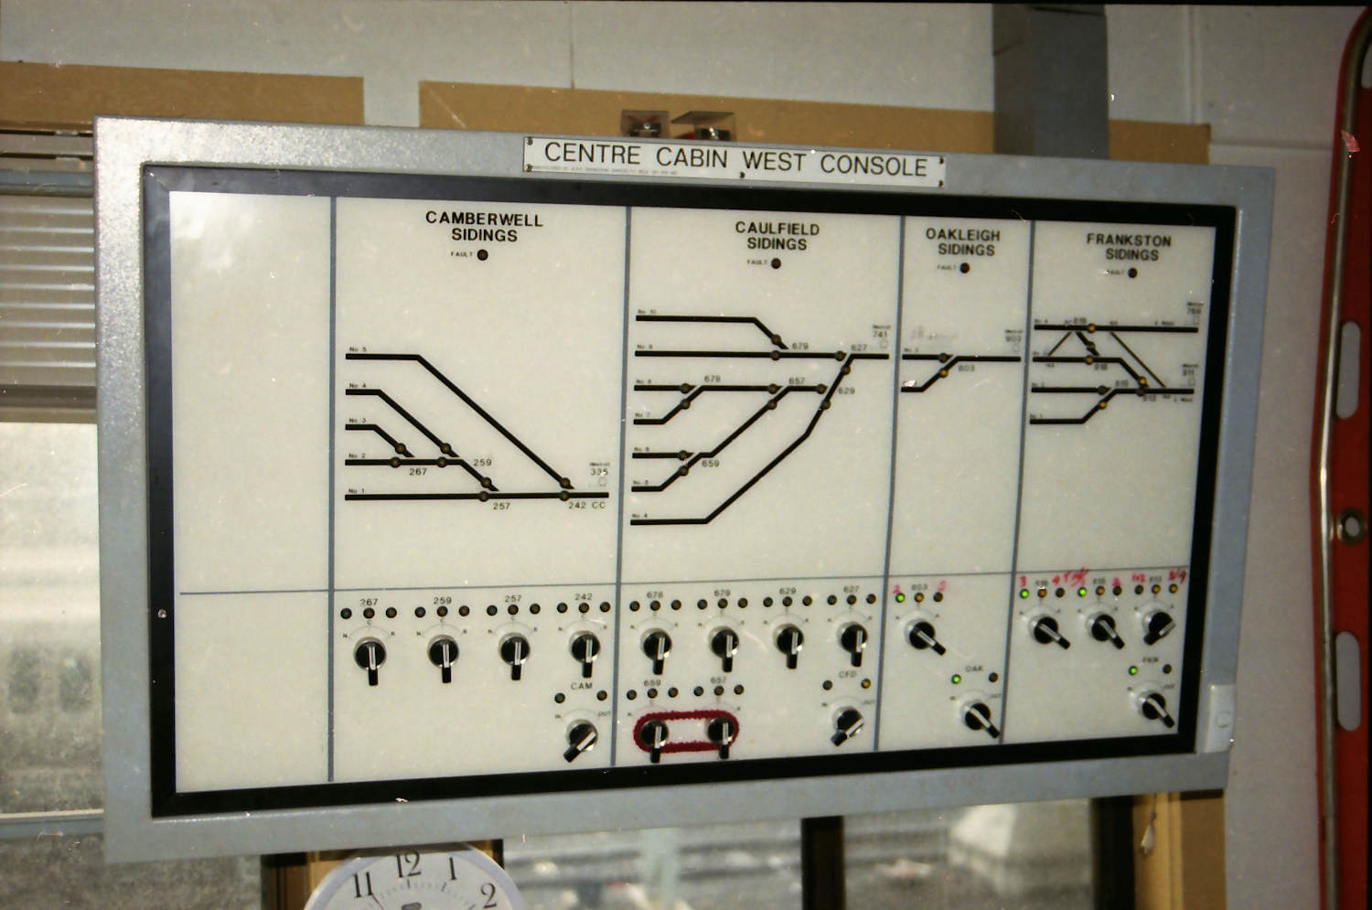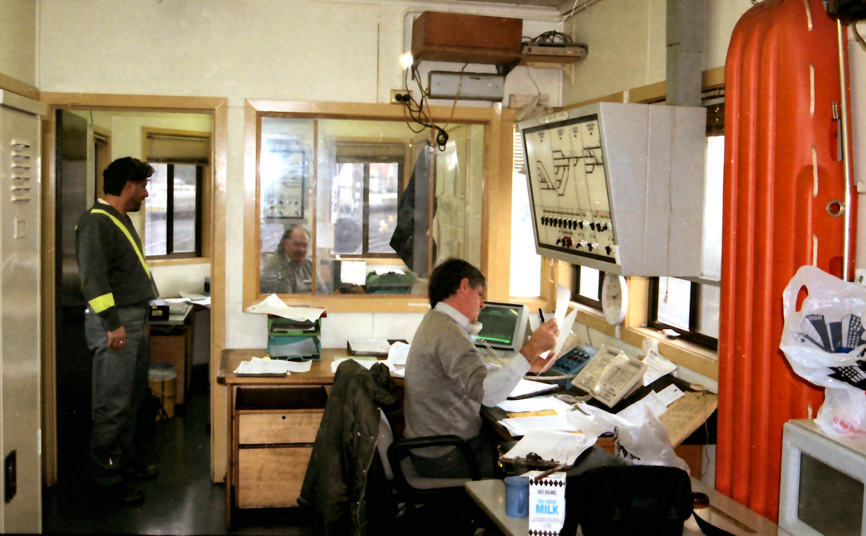Perhaps the most obscure Victorian panels were these panels installed in the Senior Fleet Controller’s Office (Yardmaster’s Office) and Centre Cabin, Flinders Street Yard, on 6 August 1995. These panels were to eliminate the need for shunters when setting the road when moving EMUs to and from the Camberwell, Caulfield, Oakleigh, Frankston, Sandringham, and Goods Yard Sidings in the Flinders Street Yard (no panel was provided for the Collingwood Sidings). The panels had an extremely short life and were abolished when Flinders Street Yard was removed as part of construction of Federation Square in 1997/8. The Goods Yard Sidings were abolished in March 1997; Camberwell Sidings in July 1997; Caulfield Sidings in January 1998; Oakleigh Sidings in February 1998, and, finally, the Frankston and Sandringham Sidings were booked out of use in March 1998. (Above) An interior shot of the Centre Cabin, with the West Console on the left, and the East Console just visible on the far wall through the window. (Below) The West Console in the Centre Cabin. The West Console could work the Camberwell, Caufield, Oakleigh, and Frankston Sidings. When this photo was taken, the Oakleigh Sidings and Frankston Sidings sections of the panel were switched in. The East Console in the Centre Cabin could work the Camberwell and Caulfield Sidings.

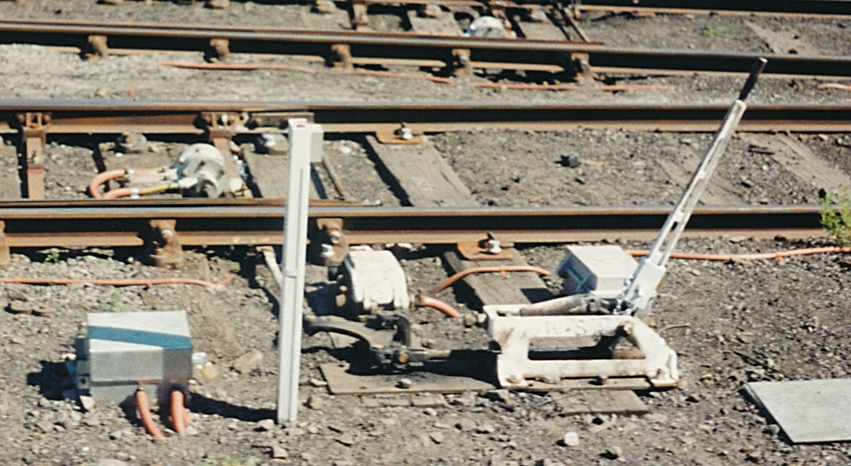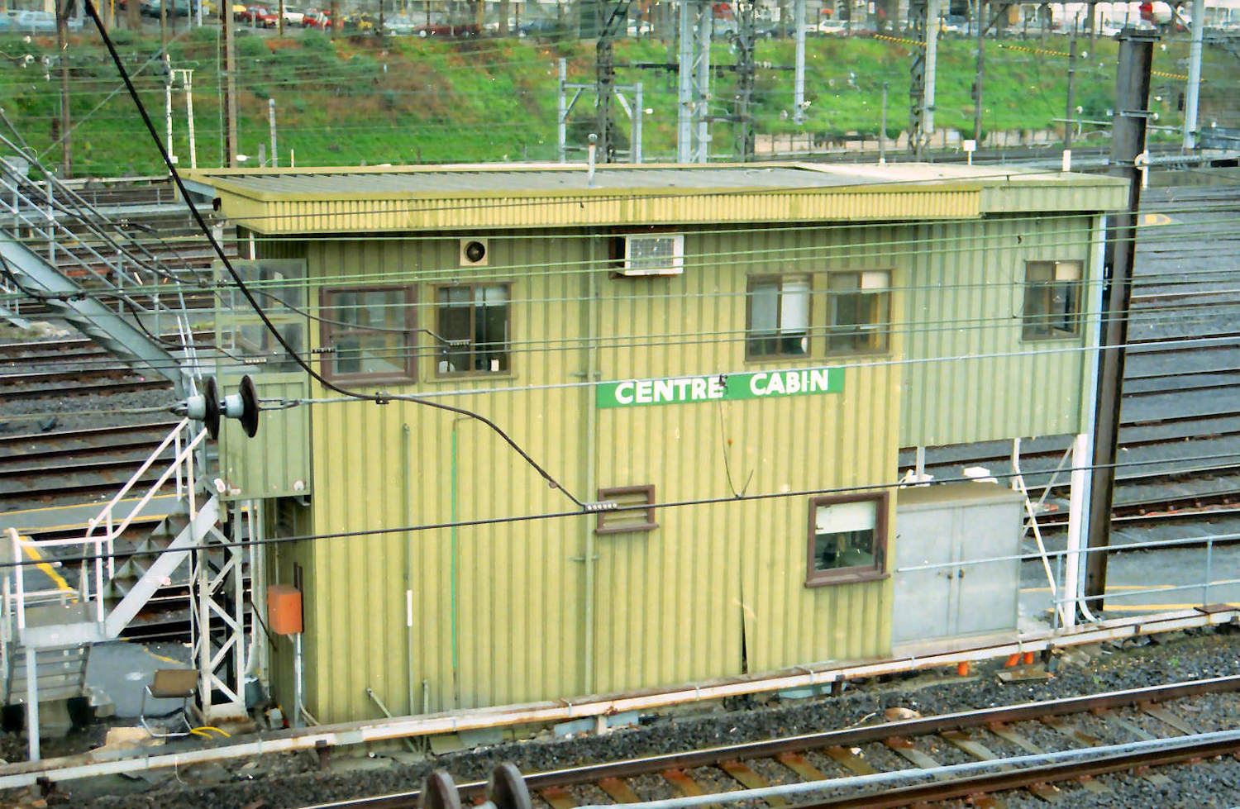(Above) As its name suggests, Centre Cabin was located in the middle of Flinders Street Yard and was accessed from the Yardmaster’s footbridge. Attractive it was not. The West Console can be seen behind the centre pair of windows on the first floor. (Below) The point mechanisms operated by these panels were not standard, as can be seen from this photograph. The points were hydraulically driven from a standard hydraulic power pack (seen at the bottom left) which was also used on clamp locked points. It seems several types of hydraulic pistons were used, with the one shown here between the point blades being the most common. No facing point locks were fitted to the points, and the points could be trailed through. The standard Westinghouse point detector was used for point indication. Manual operation of the points was possible from a slightly modified WSa lever. A keyswitch was provided (on the vertical post) to electrically isolate the points to prevent injury when it was necessary to manually operate the points. The modification to the WSa lever consisted in making the handle detachable – the socket can be seen towards the bottom of the lever. This was, of course, to prevent injury from the point lever flying backwards and forwards as the point was remotely operated. However, many of the levers seemed to be left on the point base.

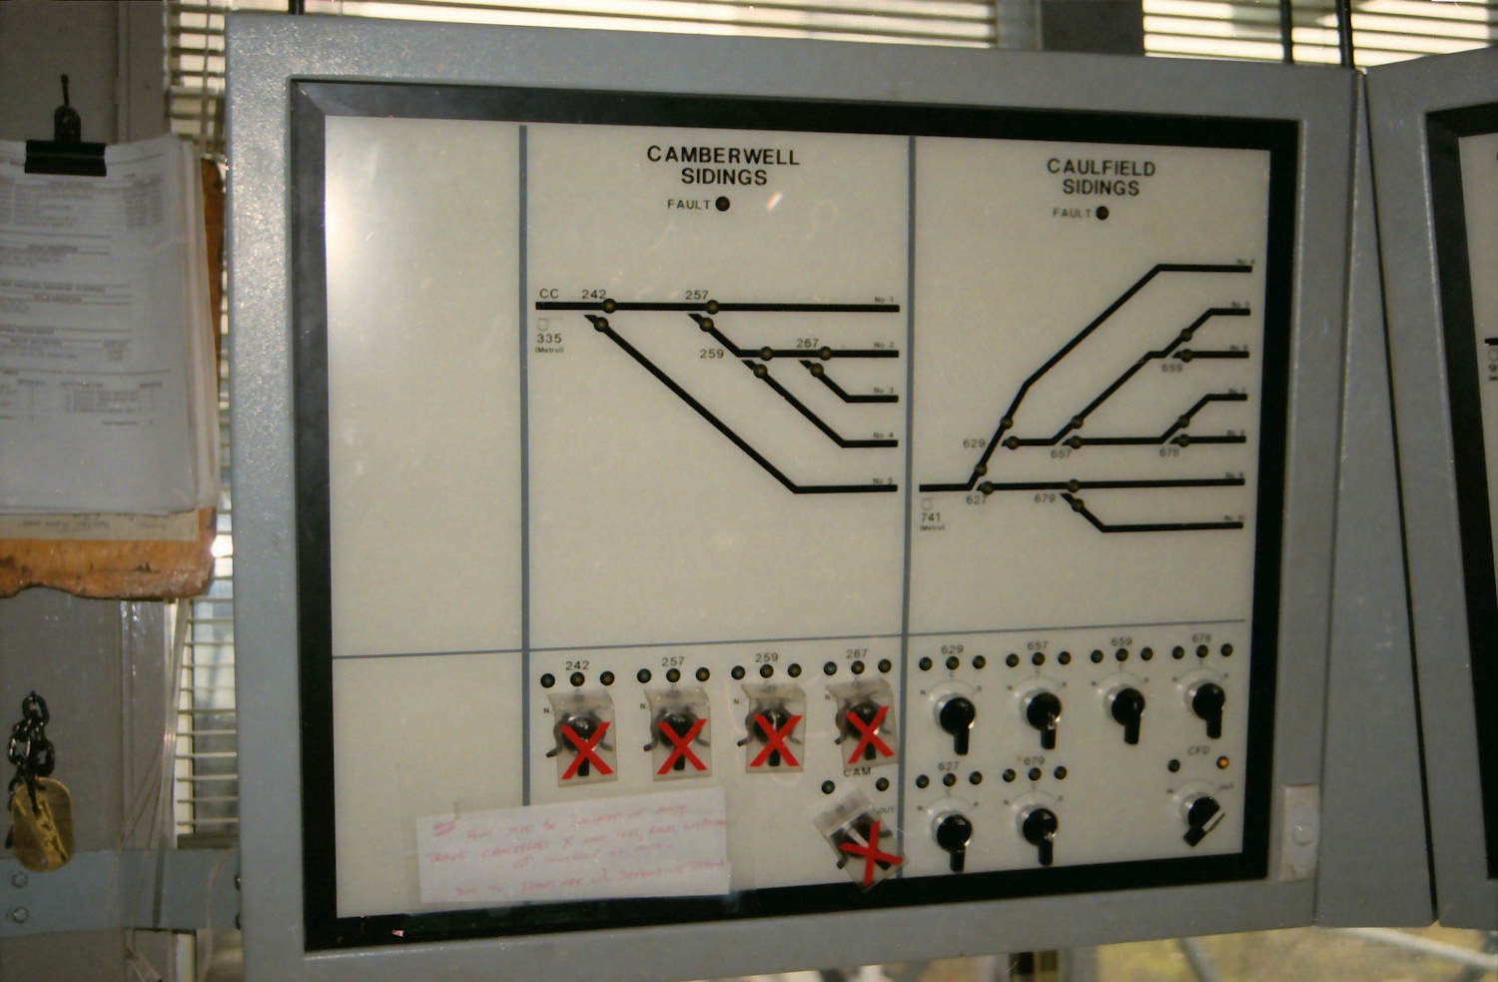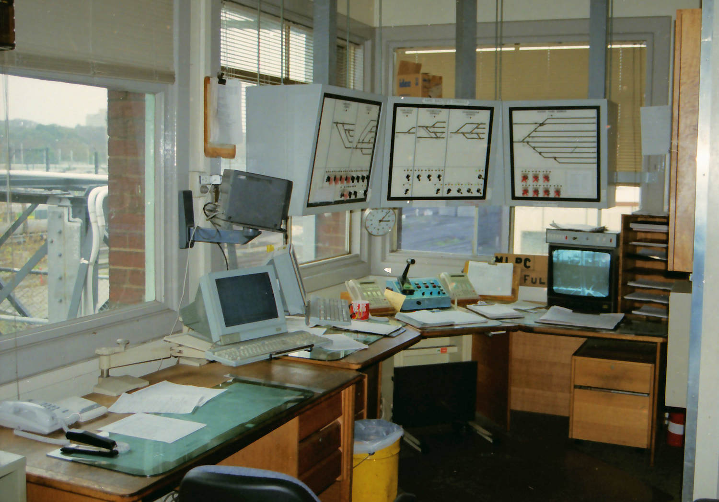(Above) A general view of the Yardmaster’s Console in the Senior Fleet Controller’s (Yardmaster’s) Office located on the south side of Flinders St Yard. These panels could operate the Camberwell, Caulfield, Oakleigh, Frankston, Sandringham, and Goods Yard sidings. (Below) A close up of the portion of the panel that worked the Camberwell and Caulfield sidings. None of these panels worked any signals; only points. All movements in the sidings required verbal authorisation via radio from the Senior Fleet Controller or their representative. Each point lever had the usual three LED lights: normal indication (green), points free (yellow), and reverse indication (yellow). The normal and reverse indications are repeated on the track diagram (yellow LEDs) in the legs from each set of controlled points. Immediately underneath the title for each section of the panel was a red ‘Fault’ LED. This flashed when a fault occurred with this section of the panel. The point levers for the Camberwell Sidings are all sleeved as the sidings were in the process of being dismantled when these pictures were taken.

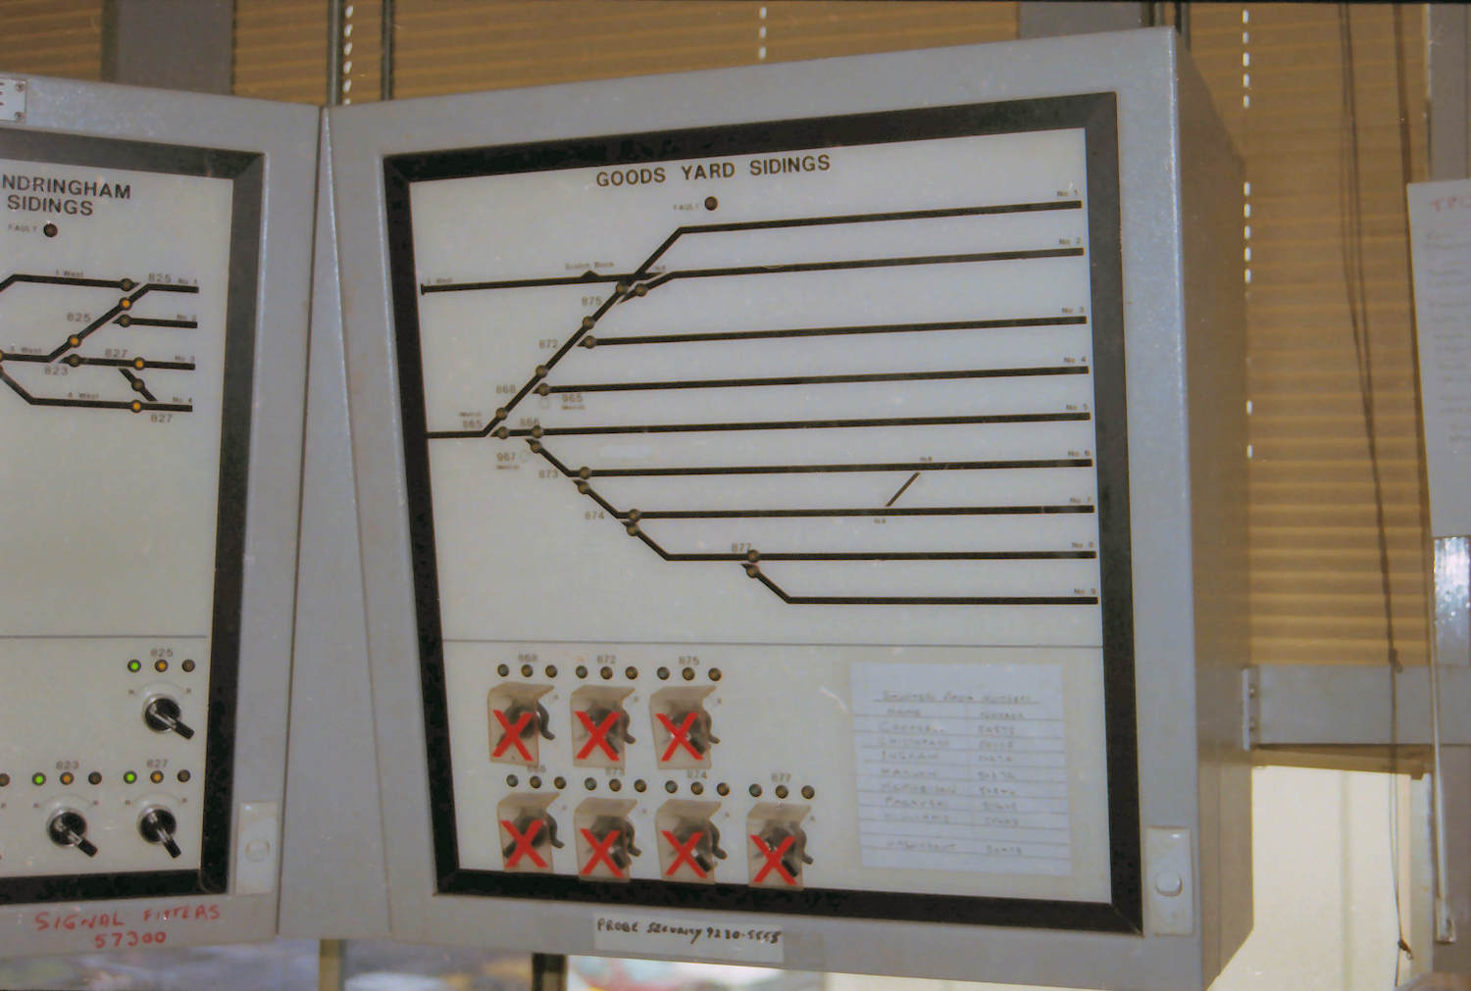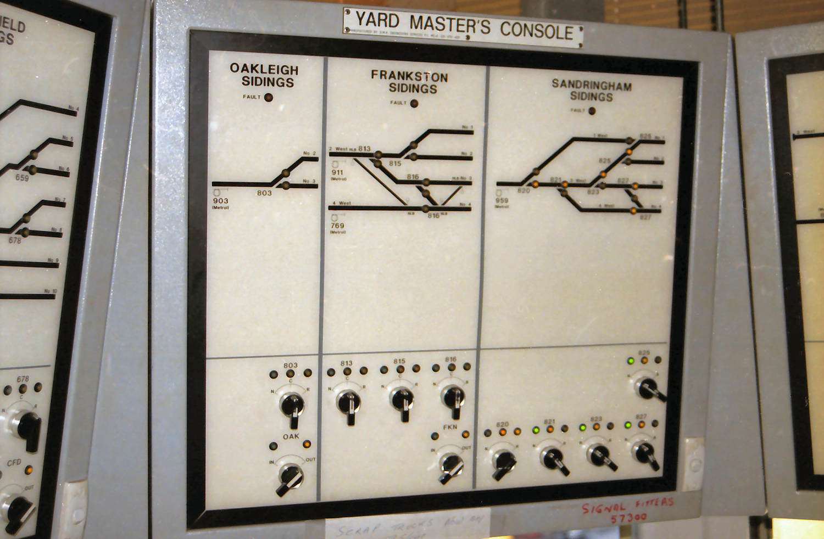(Above) The centre portion of the Yard Master’s Console which worked the Oakleigh, Frankston, and Sandringham sidings. Readers may have noticed that some sidings could be worked from more than one panel. To allow this, groups of sidings could be switched in or out, and the switching levers can be seen below the point levers on some of the panels. The LEDs above the switching lever indicated switched in (green) and out (yellow). The Yard Master’s console was the master. If it was necessary to transfer control of a group of sidings from the Yard Master’s console to one of the panels in the Centre Cabin, the Senior Fleet Controller checked with the local panel operator that all their point levers were in the central ‘switched out’ position. If so, the switch out lever on the Yardmaster’s console would be placed to ‘Out’. All lights on the affected section on the panel would then go out, except for the yellow ‘switched out light (as is the case here for the Oakleigh and Frankston Sidings)’. The indicating lights above the closing lever of the relevant panel in the Centre Cabin would begin to flash. When that switch out lever was moved to ‘In’, the ‘switched in’ LED became steady, the ‘switched out’ LED went out, the point indicator LEDs were lit, and the point levers became active. The sections for the Sandringham and Goods Yard Sidings have no switch out lever as these sidings could only be controlled from the Yardmaster’s console. (Below) The right hand portion which works the Goods Yard sidings. All photos were taken by David Langley in early 1998.

# BR930 (Style Q) Relays

Andrew Waugh

The last half of the 20th century was the era of the relay interlocking. In the 1950s, it was still possible for the members of the IRSE to debate the relative merits of mechanical interlockings, power frames, and relay interlockings. But, by the 2000s it was clear that no further large relay interlockings would be constructed; the immediate future belonged to computer based interlockings (CBIs). Today, even small resignallings use CBIs.

Signalling relays are a surprisingly neglected aspect of signalling, and this article is an introduction to the BR930 relay (more commonly known as the ‘Style Q’ or ‘Q type’ relays after the Westinghouse/McKenzie & Holland BR930 design)[1]. The BR930 type is still the standard signalling relay used in Australia (and the UK), and was developed over 55 years ago.

## UK signalling relays in the 1950s

There were three classes of signalling relays available in the UK in the 1950s: shelf relays, CTC relays, and plug-in relays.

The shelf relay was the standard relay used for vital signalling circuits. This type of relay was developed around 1900 in the United States and by the 1920s it was a mature technology. The defining characteristic of shelf relays was their physical size and weight. An example was a DC line relay with 8 front and back contacts that measured 8½x10¼x6½ inches and weighed 14lb (6.4 kg).

The design features of the shelf type relays reflected the signalling environment of the pre WWII period.

The relays were designed to be used with primary batteries; low power consumption was consequently a priority. Shelf type relays featured large coils with many wire turns to generate the necessary magnetic flux, and a ‘massive’ iron circuit to use the flux efficiently. In addition, the necessary small air gap between the pole piece and the armature required long contact fingers to obtain the specified contact clearances.

Most relays at the time had either their coils or contacts connected to external wires, and the relays had to be designed to withstand high voltages due to lightning surges. A clearance of ¼” between live metal parts was consequently required and the relay had to withstand a 2,000 volt breakdown test.

Finally, 0BA terminals were used spaced at a minimum of 1” centres. This allowed the use of a wire capable of carrying 250V and a current of 5 amperes, and tested to 1500V.

In the UK, features of the shelf type relay were standardised from 1932 as British Standards BS452 (Track Relays) and BS475 (Line Relays)[2]. The standardisation committee consisted of members from the UK railway companies, the UK manufacturers, and an IRSE representative. Unfortunately, by the late 1940s, the manufacturers realised that these standards allowed too many options. In the case of the DC line relay, the standard allowed some 432 distinct types of relay. This meant that it was difficult to achieve any economy of scale due to the small production runs. In 1949, JP Coley (of Westinghouse) presented a paper to the IRSE in which he recommended that many of these variations be eliminated. The result was a new standard, BS1659, issued in 1950. This new standard appears to have little technical innovation, its main purpose seems to have been the simplification of the requirements and the elimination of options that were not widely used.

The ‘CTC type’ relay was developed in the 1930s and was used for non-vital signalling circuits. Train describers were probably the most common application in the UK. Leggett and Candler, writing for the IRSE in 1968, imply that the inspiration for this type of relay was the British Post Office PO3000 relay, introduced “around 1932”. However, the very name of the type suggests a US origin[3], although possibly still derived from telephony practice. CTC relays were much smaller than shelf type relays, and the resulting lower armature mass meant that they were much quicker acting than shelf relays. CTC relays were not used for vital signalling circuits in the UK or US as they had metal to metal relay contacts, and it was possible that a short circuit or lightning strike could fuse the contacts. It was noted that the true CTC type relay was, in fact, slightly larger and more robust than the PO3000 relay. Catalogues from the 1950s show that CTC type relays were typically packaged in metal enclosures designed for vertical mounting.

Plug-in relays were also developed in the ‘30s. The key feature of the plug-in relay was that, instead of sitting on a shelf, they were plugged into vertical plugboard which, in turn, was mounted on a vertical frame. The three key features of plug-in relays were:

* The wiring between the relays was permanently attached to the plugboard. Replacing a relay was a simple matter of unplugging it and plugging in a replacement. This was not only faster, but much safer, as it was not necessary to retest that the correct wire was connected to the correct terminal[4].
* It was not necessary to provide space to work on the wiring around the relay. This meant the relays could be packed in much more tightly.
* The relays were smaller than shelf relays. This even further improved the density of the relays on the racks. It is quite likely that the size reduction was partially due to the need to reduce the mass of the relay to allow it to be suspended from the vertical plugboard.

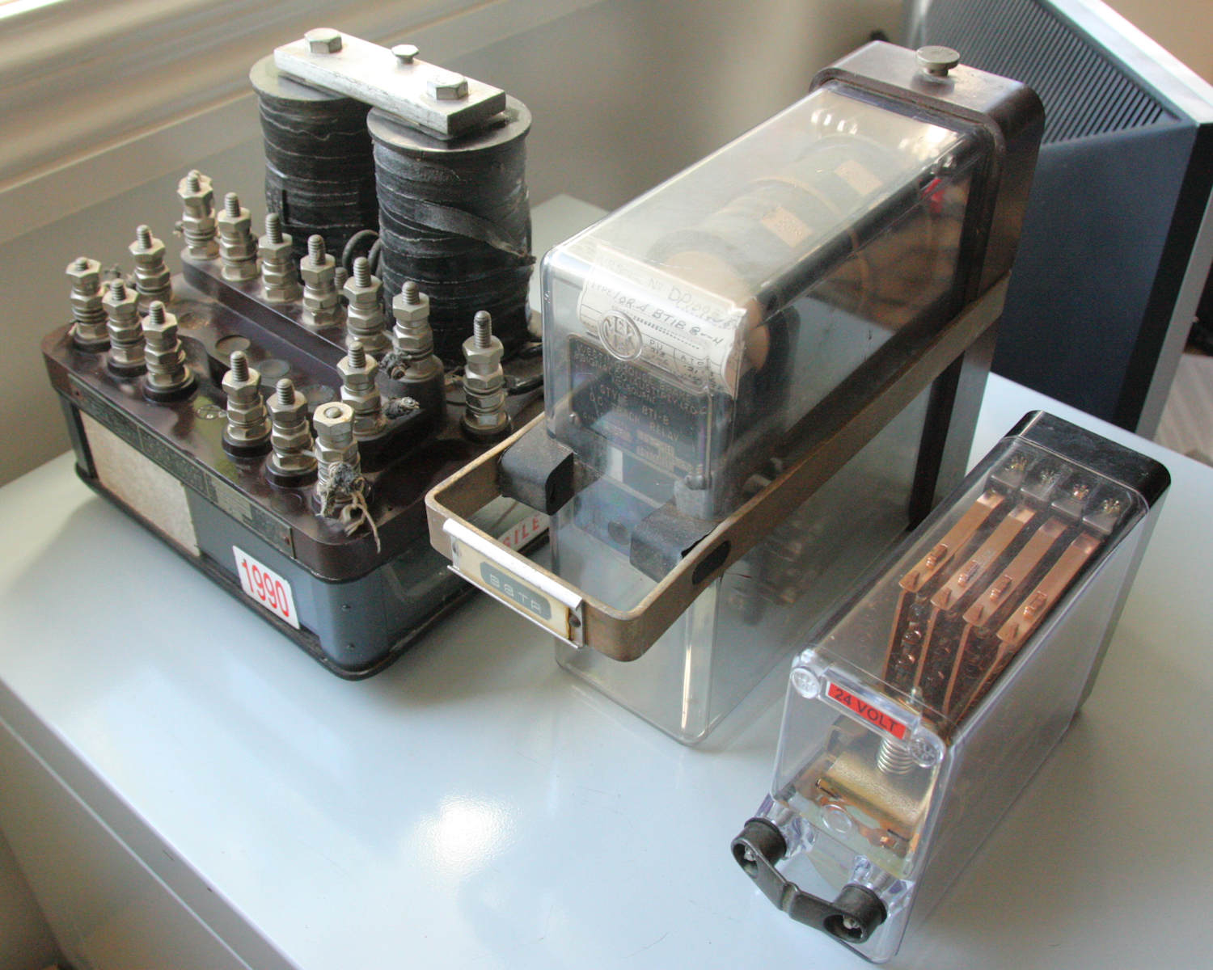Like CTC relays, the history of plug-in relays is obscure. All sources agree that they were developed in the 1930s.

Three typical DC signalling relays for the purposes of comparison. On the left is a DC shelf relay, in this case a McKenzie & Holland (Westinghouse) Style DN11 Neutral Relay. In the centre is an example of a large plug-in relay, in this case a Westinghouse Style BT1-B DC Track Relay. On the right is a Westinghouse Style Q (BR930) DC Neutral Relay. While the large plug-in relay does not appear much smaller than the shelf type relay, a large amount of space needs to be left around the shelf type relay to allow access to the wiring and so the packing density in a relay room is substantially less for the shelf relay. Notionally, all three relays have a similar number of contacts. This shelf relay can have a maximum of six dependent back and front contacts (only two of the back contacts are actually fitted). The large plug-in relay has 12 independent front or back contacts. The Style Q relay has 16 independent front or back contacts. However, in practice the plug-in relays are substantially more flexible as they provide independent contacts.

It is known that GRS introduced their Type B plug-in relay in 1935 in the US, and by 1940 was marketing a range of relays based on this relay design. They were still available in 2011, and by that date over two million had been sold. A Type B1 relay was 6 5/16” high by 2 7/16” wide by 8 9/16” deep and weighed 7 to 10 pounds with plug board. The Type B2 relay was identical, except that it was exactly double the width of the Type B1 relay. Type B2 relays were used when the relay mechanism was simply too bulky to fit within a Type B1 relay case, or when more contacts were desired than could be fitted on a Type B1 plugboard. A very important feature of the Type B relays was that a number of different relay types could be fitted within the standard Type B1 and B2 relay cases. In 1940, the available B1 relays were a DC neutral relay, and a DC thermal (timing) relay. B2 relays available were a DC neutral relay (with more contacts), a DC neutral polar relay, a DC retained-neutral polar relay, and an AC vane relay. Pins were used to ensure that the correct type of relay was plugged into the plug bases. Union Switch & Signal (USS) had a very similar series of relays known as the Type PN relays, but I know little of the history of them. This is a pity, as the UK Westinghouse Brake & Signal Company was closely associated with USS.

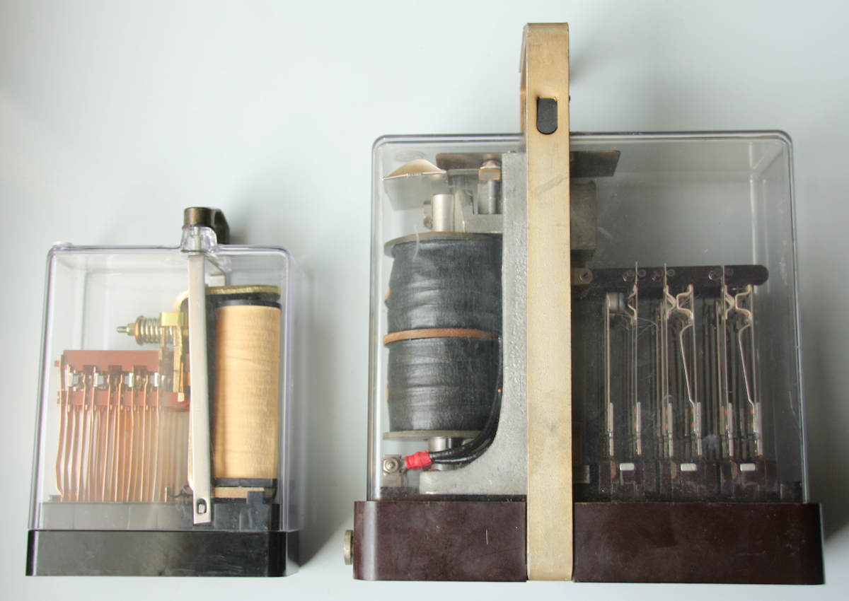By the 1950s, Westinghouse in the UK had developed a series of plug-in relays, which were very similar in concept to the GRS Type B relays. They were, however, larger than the GRS Type B relays, at 8 3/16” high by 3 1/4" wide by 9 3/4” deep, and heavier, starting about 12 pounds in weight. The slightly larger size may have been due to the need to largely conform to BS1659:1950[5]. Like the GRS relays, the Westinghouse plug-in relays came in single width and double width sizes, and a large variety of relay types were packaged in the same basic shape. These included DC Biased Line Relays, DC Neutral Line Relays, DC Biased Line Polar Relays, DC Polarised Line Relays, DC Neutral Polar Relays, DC Thermal Time Element Relays, DC Biased Slow Release Relays, DC Slow Pickup Relays, AC Relays, AC 2 element 3 position Vane Relays, and AC Thermal Time Element Relays.

A comparison of a Style Q (BR930) relay (left) and the older large plug-in relay BT1-B (right). This shows the substantial reduction in size achieved in the BR930 relays. Both relays are orientated so that the top of the relay is to the left – note that in the BR930 relay the coil is below the contact fingers at the bottom of the relay, while in the large plug-in relay the coil is above the contact fingers.

## Challenges with shelf relays

In the mid 1950s, it was clear that relay interlockings would play an important role in British signalling. The economic dividing line between mechanical and relay interlockings, however, was not clear cut. One problem was the cost of the many relays necessary to implement a relay interlocking – this cost was not just the relays themselves, but the cost of the relay room that housed them and even the wire that connected them.

The statistics for the York resignalling illustrate the issues at that time. York was the first very large relay based resignalling project in the UK. Brought into use in 1951, it replaced eight mechanical signal boxes. The relay room at York contained 2885 relays “of various types”, but the published photos of the relay room show AC shelf type relays. The relay room itself was huge: 144 feet long and 34 feet 6 inches wide. This space did not include the external cable terminations; these were on a lower floor. The internal wiring in the relay room required the truly astonishing amount of over 400 miles of single core cable, with individual runs ranging from 5 feet to over 50 feet. This does not include the wiring between the field and the relay room, or the relay room and the panel.

(Left) Another photograph showing the difference between large plug-in relays and the BR930 relays. This is part of the interior of the relay box at Wodonga Coal Sidings after it had been stripped of relays, leaving just the plugboards. Most of the plugboards are for the large plug-in relays, with a single BR930 plugboard in the upper row, second from the left. A jumper plate has had to be used to mount the far smaller BR930 plugboard on the relay rack meant for a large plug in relay. Note the double width plugboard in the lower row – this was probably for an AC vane relay.

Turning to the features of the large plugboard, the two flat pins at the top are the connectors for the relay coils. The round pins about halfway down the plugboard are the registration pins that prevent the wrong type of relay being plugged into the plugboard. The sockets in the lower half are for the contact spring pins.

The BR930 plugboard is similar, but inverted, and all the pins are on the relay. The contact spring connectors are the rectangular grid of 32 holes at the top of the plugboard. The four coil connectors are below this, two on each side of the plugboard. The dots at the bottom of the plugboard, surrounding the circular hole, are markings for the registration holes. The wire loop projecting forward from the relay is the mechanism used to secure the relay in the plugboard.

At a 1956 IRSE discussion on signalling miniaturisation, E.A. Rogers noted that a typical plug-in relay occupied 40% of the rack area of a shelf relay per contact, reducing the cost of the relay room by 28%. On the other hand, the price of the relay, per contact, was about 132% of the shelf type relay. So, the savings on the relay room were offset by the increased cost of the relays.

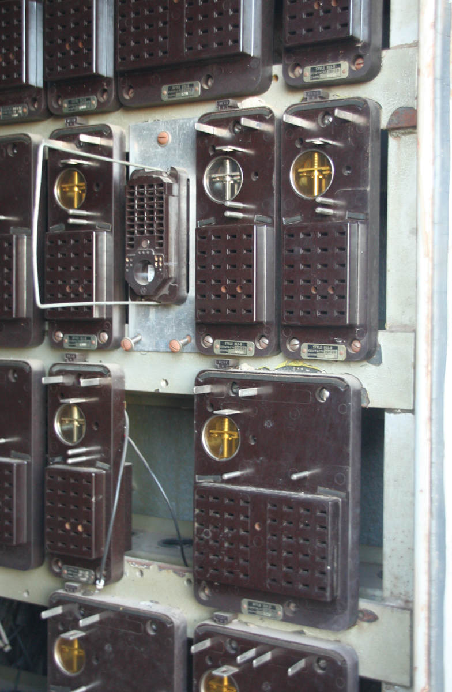Other types of relays, however, were even smaller. European signalling used relays that were that were the same cost as shelf relays per contact, but which occupied 15% of the space per contact, giving a relay room cost 29% of a UK relay room. This was achieved by using metal to metal contacts in relays, which, however, required additional contacts in the circuits to prevent the possibility of the front contacts welding. The Post Office telephone type relay was a mere 6% of the size per contact, and 18% of the cost per contact, with a resulting relay room cost of 19%.

It is not surprising that, by the mid 1950s it was becoming obvious that significant cost reductions could be obtained by reducing the size of signalling relays. The more internationally aware UK signal engineers were well aware of the much smaller signalling relays used in the rest of Europe.

## The development of the IRSE relay specification

The originator of the BR930 relays appeared to be the 1956 president of the IRSE, J.C. Kubale[6]. Kubale asked E.A. Rogers to lead an informal discussion at the IRSE on 19 November 1956 on the ‘Miniaturisation of Railway Signalling Apparatus’. This discussion particularly focussed on relays.

It would have been possible for one of the signalling manufacturers to ignore the BS1659 and design a more compact signalling relay. Indeed, Westinghouse developed their Style P miniature plug in relays in the late 1950s. But the discussion at the IRSE in 1956 showed why this was commercially risky. A significant number of signal engineers at the meeting did not see the necessity for reducing the size of the relays. They considered the relay cost a relatively small part of the total cost of a signalling scheme, and were concerned that moving away from BS1659 would reduce safety. Given the ambivalent reaction of their customers, it is understandable that the signalling companies wanted to progress under the auspices of the IRSE.

The IRSE council duly set up a ‘Miniaturisation Committee’ in 1957 to ‘investigate the desirability and practicability of ‘miniaturisation’ in railway signalling’. The members of the committee were J.C. Kubale (chair), J.F.H. Tyler (vice-chair), T. Austin, E.G. Brentnall, A. Cardani, S. Crosbie, J.H. Currey, J.S.S. Davis, E.A. Rogers, and D.G. Shipp. This was a high powered committee; in 1957 Tyler and Shipp were the IRSE vice-presidents; Austin, Brentnall, and Kubale were past presidents; and Davis and Rogers were on the IRSE council. Given the discussion in 1960, I would suspect that this committee was, to use the modern term, to get ‘stakeholder buy-in’. That is, the committee consisted of senior people in the stakeholder organisations (the customer – the British Transport Commission - and the manufacturers) in an attempt to ensure that the organisations would support the eventual recommendations.

This committee set up four sub-committees, of which only the committee dealing with relays actually progressed.

Membership of the original relay sub-committee consisted of J.F.H. Tyler (chair), A. Cardani, J.H. Currey, E.A. Rogers (all from BR), J.P. Coley (Westinghouse), Mr Riddle (SGE), and Mr Crosbie (AEI-GRS). The membership changed, of course, over time.

In 1968, J.E. Chandler described the design process[7]: “The Committee very nearly did not begin because the first two meetings were occupied by what he would describe as wrangles as to whether or not the railways should be allowed to make a specification which was going to enforce a certain design on the manufacturers, who wanted to keep their freedom of design. Later it became evident that the railways only wanted to say what they wanted. They did not want to interfere in the design work. There were, however, other difficulties, because each of the companies who were interested in the design naturally wanted their own to be adopted as a standard and it was nearly a year before they really got down to what in English are called ‘brass tacks’ […]. The design work actually was done by the designers listening to the warring requirements of the different Regions of British Railways, coming to some compromise, then going away to see what it was possible to meet. Then, at the next meeting, the various ideas of the designers would be put forward and after a whole series of meetings, as one could well imagine, they would arrive at some common agreement. But it was a very long and tedious process in the beginning.”

The specification for a DC neutral relay had been completed by December 1960 when J.P. Coley presented a paper on it to the IRSE. Amusingly, the paper is illustrated by photos and drawings of the Westinghouse Style P miniature plug-in relays (PNI – Neutral; PSRI – Slow Release; PSPI – Slow Pick-up; PL2 – Latched; PNIA – AC immune neutral; PPWR1 – Polarised Point Contactor; and PWK1BA – Polarised three position) and the AEI-GRS miniature plug-in relays (Style AS Neutral Relay, Style AI Immunised Neutral Relay). None of these relays appears to conform to the IRSE specification, Coley mentions that they were designed before the publication of the IRSE specification. The only relay in the paper that was conformed to the new specification was the SGE neutral relay.

The sub-committee was subsequently promoted to be a full committee of the IRSE and continued for a number of years to develop variants of this initial specification for different types of relays.

## Design features of the IRSE relay

The IRSE relay was a considerable reduction in size compared with previous UK/US plug in relays. Overall, the size was 4 3/4" high, 2 3/16” wide, and 7” deep (including handle).

The main design features of the new relay design that allowed a smaller physical size were the relay coil/iron circuit, the wire connectors/ external wires, and a reduced contact area.

As already mentioned, relays had traditionally been designed to draw minimal power when energised. A 1000 Ohm BS1659 relay on a 12 Volt supply drew only 0.144 Watts. The new specification allowed a maximum current draw of 3 Watts with a minimum voltage of 24 Volts. This increased power consumption allowed a very significant reduction in size of the relay coil and size of the iron circuit carrying the magnetic flux. By 1960, of course, central power supplies and auxiliary diesel generators meant that the increased power consumption was of far less significance than in the 1920s.

The second significant size constraint was simply connecting the necessary coil and contact wires to the relay. The existing plug in relay design from Westinghouse had already moved from the 0BA terminals. Instead, the plugboard had removable contactors to which up to two wires could be soldered. This general design was followed for the new miniature relays. The need to put two wires and a removal tool into the hole in the plugboard dictated the minimum spacing between the connectors. No useful reduction in spacing could be made with the then existing 0.18 inch wire, and it was necessary to change to a wire of 0.110 inch diameter (copper conductor of 0.044 inch). With this smaller size of wire, the spacing of the connectors was limited by the contactors inside the relays.

The contactors were reduced in size, though the gap between the front and back contacts was maintained. Experiments were conducted to ensure that the smaller contacts were capable of driving typical loads (three relays in parallel, a DC fed 25 watt signal lamp, or a DC fed 25 wat signal lamp through a 110/12V transformer) one million times without a significant reduction in contact pressure.

It was recognised that making the front contacts metal to metal would result in a useful cost saving. British practice was to make the front contact carbon to metal to ensure that the contacts could not weld together if the relay was deenergised with current flowing through the contacts. European practice was to use metal to metal front contacts, but this required more complex signalling circuits that proved the opening of the contacts. Tests were conducted that showed welding could occur if a metal to metal contact opened carrying a 5 amp current[8]. Given the relatively small cost saving of using metal to metal contacts, it was decided that the resulting risk and complexity would not be worthwhile.

Some features of the new relays had nothing to do with miniaturisation, and probably reflect horse trading between the manufacturers and the customer, the BTC signal engineers.

The manufacturers wished to remove some of the requirements in BS1659, for example the requirement that all contacts should make and break at the same time. This required considerable fiddly adjustment when constructing relays. In the new IRSE specification this was weakened to requiring that all the contacts open and close within a reasonably short time.

The key feature added to the specification, of benefit to the customer but not to the manufacturer, was interchangeability of relays and bases. Any relay from any manufacturer was required to fit into a plugboard from any manufacture. This was a major benefit to BR (and other railways) as it meant that manufacturers had to compete for business.

## The BR930 relays

Having prepared the original specification, the IRSE faced a challenge in publishing it. The IRSE could not finance the printing costs involved and the IRSE council consequently agreed that the specifications, as they were prepared, would be offered to BR. If accepted, they would be published as BR specifications. Rogers noted in 1968 that, while this was a practical solution that had worked effectively, it meant that the relays were known as the BR miniature relays and the IRSE failed to get any acknowledgement.

By 1968, the IRSE relay miniaturisation committee had compiled no less than eighteen relay specifications:

* 930 – DC Neutral Line Relay
* 931 – AC Immune DC Neutral Line Relay
* 932 – AC Immune DC Biased Neutral Line Relay
* 933 – AC Immune DC Slow Pick-up Neutral Line relay
* 934 – AC Immune DC Slow Release Neutral Line relay
* 935 – DC Magnetically Latched Neutral Line relay
* 936 – DC Polarised Magnetic Stick Line relay
* 937 – DC Neutral Thermal Time Element relay
* 938 – DC Neutral Track relay
* 939 – AC Immune DC Neutral Track relay
* 940 – DC Single Wound Lamp Proving relay
* 941 – AC Lamp Proving relay
* 942 – AC Lamp Proving relay for Junction Indicators
* 943 – AC Immune, DC Biased Contactor Relay
* 949 – DC Non-Safety Time Delay Relay Unit (for use in point control circuits)
* 960 – Twin DC Neutral Line relay unit
* 961 – Twin AC Immune DC Biased Neutral Line relay unit

(Relay types above 939 were still provisional or draft in 1968, and had not been formally adopted by BR, but were later formally issued – BR940, BR941 & BR942 in May 1972, BR943 in February 1971, BR949 in May 1972, and BR961 in February 1972.)

By 1968, the manufacturers skills in miniaturisation had so improved that they could fit two complete independent relays into one BR930 case – these were the BR960 and BR961 ‘twin relay’ specifications. Since the number of wires connecting to the relays could not be increased, these were only useful for circuits with a small number of contacts. Subsequently two further twin relay specifications were developed – BR962 (DC neutral thermal time element/DC neutral line relay), and BR963 (Twin DC slow-acting neutral line relay) in October 1971.

It is worth noting that there were no specifications for AC relays in the BR930 series. The reason for this appears to be that it was found that it was cheaper, and more space efficient, to rectify the AC to DC and drive a standard BR930 DC relay. In this context, it should be noted that signalling manufacturers were early adopters and developers of solid state rectifiers. By the end of the twentieth century, AC relays were considered less safe than DC relays as they required considerable care to be paid to the phase of the power supply.

By 1968, Rogers noted that there were some 150,000 BS930 type relays in use on BR alone. Further, the relay was, per contact, less than half the cost of the original large plug-in relays. They were also one third the size of the original large plug-in relays which must have resulted in substantial additional savings in relay rooms and wiring. Leggett & Candler illustrated their paper with BR930 relays from Westinghouse, GRS-AEI, Tyers, SGE, and AGS.

## Westinghouse Style Q relays

Westinghouse rapidly brought to market a new family of relays that conformed to the IRSE/BR930 specifications. These were known as the Style Q relays, and were so popular that the term ‘Q type’ or ‘Style Q’ relay is synonymous in many places with BR930 relays.

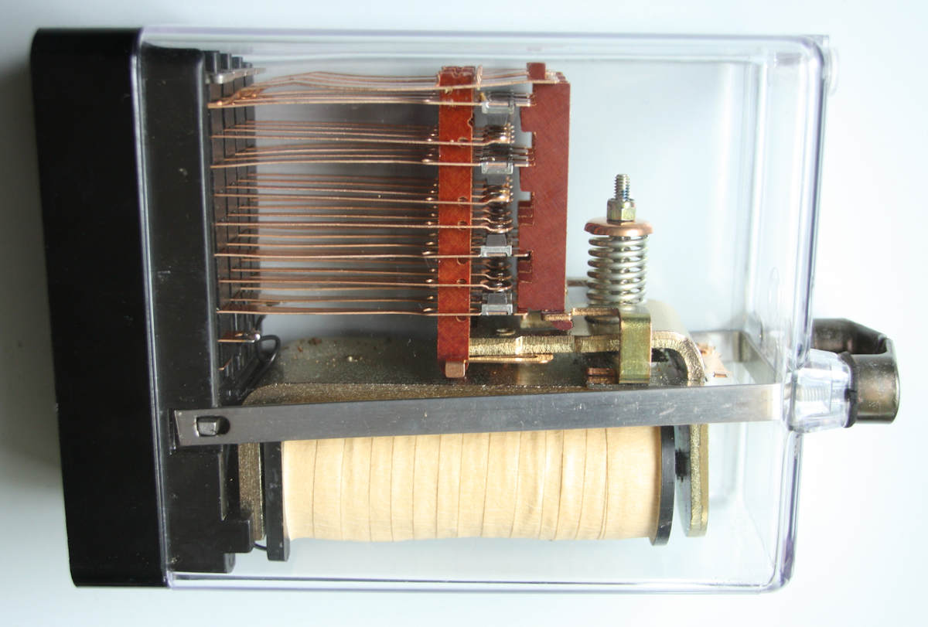The following general description of a Style Q relay was given in a 1983 Westinghouse data sheet. It should be noted that all manufacturers improved and altered the construction details of their relays over time, and the details of this description may not be accurate for very early Style Q relays.

The Style Q relay is built on a robust thermoset base moulding into which up to four vertical contact stacks may be fitted. Contact springs are separated by glass filled polycarbonate spacer blocks and are insulated from the contact stack securing screw by a nylon tube. Each vertical contact stack can carry up to four independent contacts, which may be front or back according to how they are assembled. Each outside stack also carries two coil connectors.

The side view of a Westinghouse Style (BR930) relay which can be compared with the description given below. On the left is the plastic base. The relay coil is at the bottom of the relay, with the L shaped heel piece to the left and above the coil, partially hidden by the metal bar leading to the handle. The L shaped armature is to the right and above the coil, and the spiral spring that assists the armature to drop is clear. The phosphor bronze contact springs are in the upper half of the relay. The right (toothed) SRBF card supports the fixed contact springs in their correct position. The left SRBF card is moved vertically by the armature and drives the moving contact springs. The actual contacts are between the two cards.

The magnet assembly is mounted on the base moulding below the contacts and consists in its simplest form of an “L” shaped heel-piece, a core with retaining nut to hold the heel-piece onto the base moulding, and an armature. The armature pivots on the front face of the heel-piece and is located by a phosphor bronze pivot plate. Reliable and consistent release is assured by a fixed phosphor bronze residual pin rivetted into the armature face. The coil is wound on a separate bobbin which is subsequently fitted over the core. A label fitted to the coil indicates the number of turns and nominal resistance. Actual resistance is within +/- 10% of nominal value. Wire of not less than 0.1 mm diameter is used for coils.

Contact springs are phosphor bronze and the rear ends form the plug contacts which engage with the plugboard on which the relay mounts. The front ends carry the contact tips which are silver impregnated graphite (SIG) for the fixed contacts and silver for the moving contacts. The silver contacts are rivetted and soldered to their springs. SIG contacts are attached by clips and the rear face soldered to the spring.

The moving springs are driven from the armature by operating arms blanked from synthetic resin bonded fabric (SRBF) sheet. The fixed springs are supported in their correct locations by adjustment cards blanked from SRBF sheet which are supported at the lower end by a bracket which is rivetted, with the pivot plate, to the heel-piece. At the upper end the cards are retained by support springs which also provide an upper bearing for the operating arms to slide in.

Low rate contact springs are used so that the pressure of the fixed contact against the adjustment card is nearly the same as the final contact pressure, ensuring very little change in contact pressure with wear over the life of the relay.

Armature release torque is provided by a combination of a low-stressed helical spring, gravity, and front contact pressure.

The transparent polycarbonate cover is retained by two nuts which also retain the handle. These are attached to a stales steel strap which conveys the tension of retaining the cover to the relay base preventing stress in the working parts of the relay. Plastic seals are fitted into the handle to prevent unauthorised access.

A clip-on label is provided on the front face of the cover for circuit function or similar information.

On the rear face of the relay below the contacts, five coding pins are provided to prevent the relay being fitted to an incorrect plugboard. These pins are retained by a plat which is also sealed. All parts which are insulated from other parts are tested to 1000 volts RMS. This also includes tests between windings on double-wound coils.

The matching description of a Style Q plugboard was:

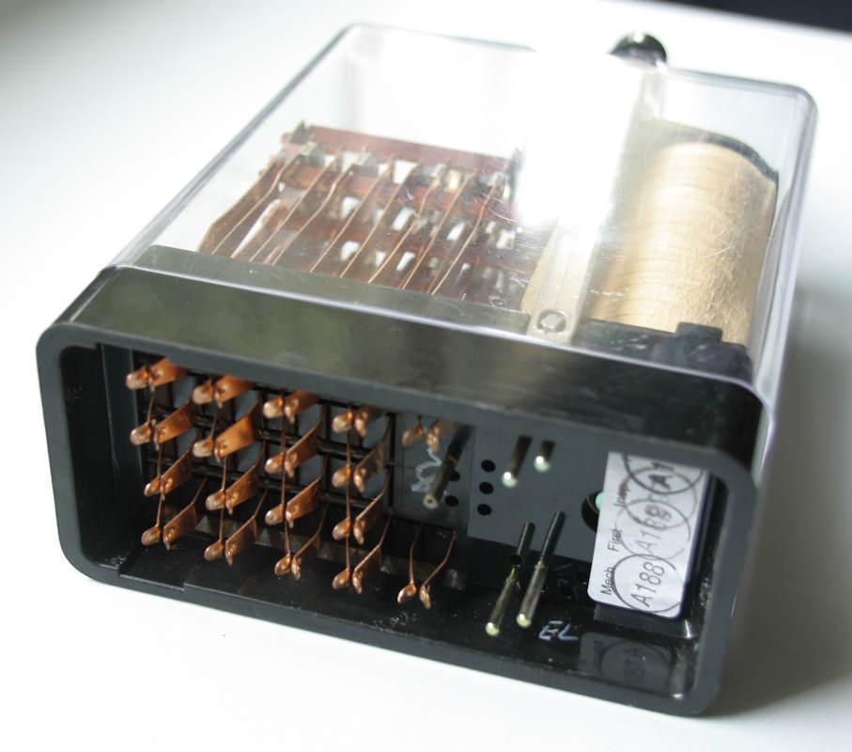Style ‘Q’ Relay Plugboards are one piece thermoset mouldings, fitted with removable crimp type connectors. These connectors provide for both wire and insulation support for one or two wires each. Connectors are suitable for soldering if desired.

Recommended cable is size 9/0.3mm, with a maximum [outside diameter] of 3mm

The relay is retained on the plugboard by a wire clip which engages in a groove in the top of the relay handle. A paper label fixed to the plugboard gives details of its associated relay.

Manufacturers have taken the opportunity to package other type of electronic/electrical equipment in the standard BR930 case. For example, Westinghouse packaged rectifiers within the standard case. It was also possible to package non-standard relays for specialised purposes in the standard case. Finally, manufacturers now offer ‘solid state’ (i.e. digital) replacements for traditional relays in the standard BR930 case.

Style Q relays are still available today from Siemens Rail Automation, as Westinghouse Brake & Signal Australia is now known. Other signalling manufacturers also offer BR930 relays. It is interesting that even as late as 1986, Westinghouse Australia offered a limited range of the large plug-in relays, and even several varieties of DN11 DC shelf type relays.

## Victorian Railways plug-in relays[9]

A view of the rear of a BR930 relay showing the plug contacts which are the extension of the contact springs. There are 16 plug contacts arranged in a 4 by 4 array. Below these are two further plug contacts for the relay coil, one on each side of the relay. The five steel pins are registration pins to ensure that only the correct type of relay is plugged into a plugboard. The registration pins are in positions BDEGX which show that this is a Westinghouse QT2 neutral track relay (a variant of a BR938 relay) designed to work with CSEE track circuits.

The duplication and electrification of the Eastern line in the late ‘50s and early ‘60s saw the first major use of relay interlockings in Victoria. The earliest relay interlockings on this project used shelf type relays. This included Pakenham (1954), Nar Nar Goon (1954), and Berwick (1956). An IRSE paper on the Eastern line resignalling noted that temporary relay interlockings installed as stage work during the duplication would use shelf type relays, but the permanent installations would use plug-in type relays. These were almost certainly the large Westinghouse plug-in relays. It is known that Trafalgar (1958) used this type of relay. It appears that the resignalling between Darling and Glen Waverley (1958) also used large type plug in relays.

Large plug-in relays continued to be used for new work until 1965. Known interlockings that used large type relays were Burnley (1960), Blackburn (1960), Mitcham (1960), Albion Junction (1961), the NE standard gauge line (1961/2), Camberwell (1964), Ferntree Gully (1964), Upper Ferntree Gully (1964), Upwey (1964), and Belgrave (1964). Other interlockings that almost certainly used large type plug-in relays were Dynon (1960), Flinders St E (small local panel) (1960), the local interlockings on the NE standard gauge (1961/2), Moonee Ponds Creek Junction (1962), Reversing Loop Junction (1962), and Wodonga A (1964). It appears the last relay interlocking to use large plug-in relays was Lalor (1964).

Carey notes that the BR930 relay was introduced in Victoria in 1965, however, a table in the paper suggests that the first relay interlocking to use this technology may have been Glen Waverley in 1964. Possibly this was a trial, as the next interlocking, Lalor, used large plug-in relays. Thereafter, new relay interlockings used BR930 relays, starting with Williamstown in 1965. Glenroy (1965), and Laverton (1965) probably also used BR930 relays.

One of the features of plug-in relays is that a variety of non-standard relays can be packaged in the standard BR930 case and use the standard plugboard. This example is a Westinghouse Style QTD5 timer which has a programmed delay of 3 to 300 seconds between the coil being energised and the relay picking up. The construction is essentially the same as the standard QN1 neutral relay, with one of the banks of contacts being replaced by a printed circuit board implementing the timer. The contacts normally used for this removed bank are used to set the delay by strapping across the plugboard. This example was stamped with a manufacturing date of May 1964.

It would appear that the last relay interlocking to be brought into use in Victoria was Ballarat (1992). Subsequent interlockings have been various forms of CBI. However, mention must be made of Menzies Creek, where the semi-automatic working introduced in 2006 makes extensive use of BR930 relays.

## Conclusion

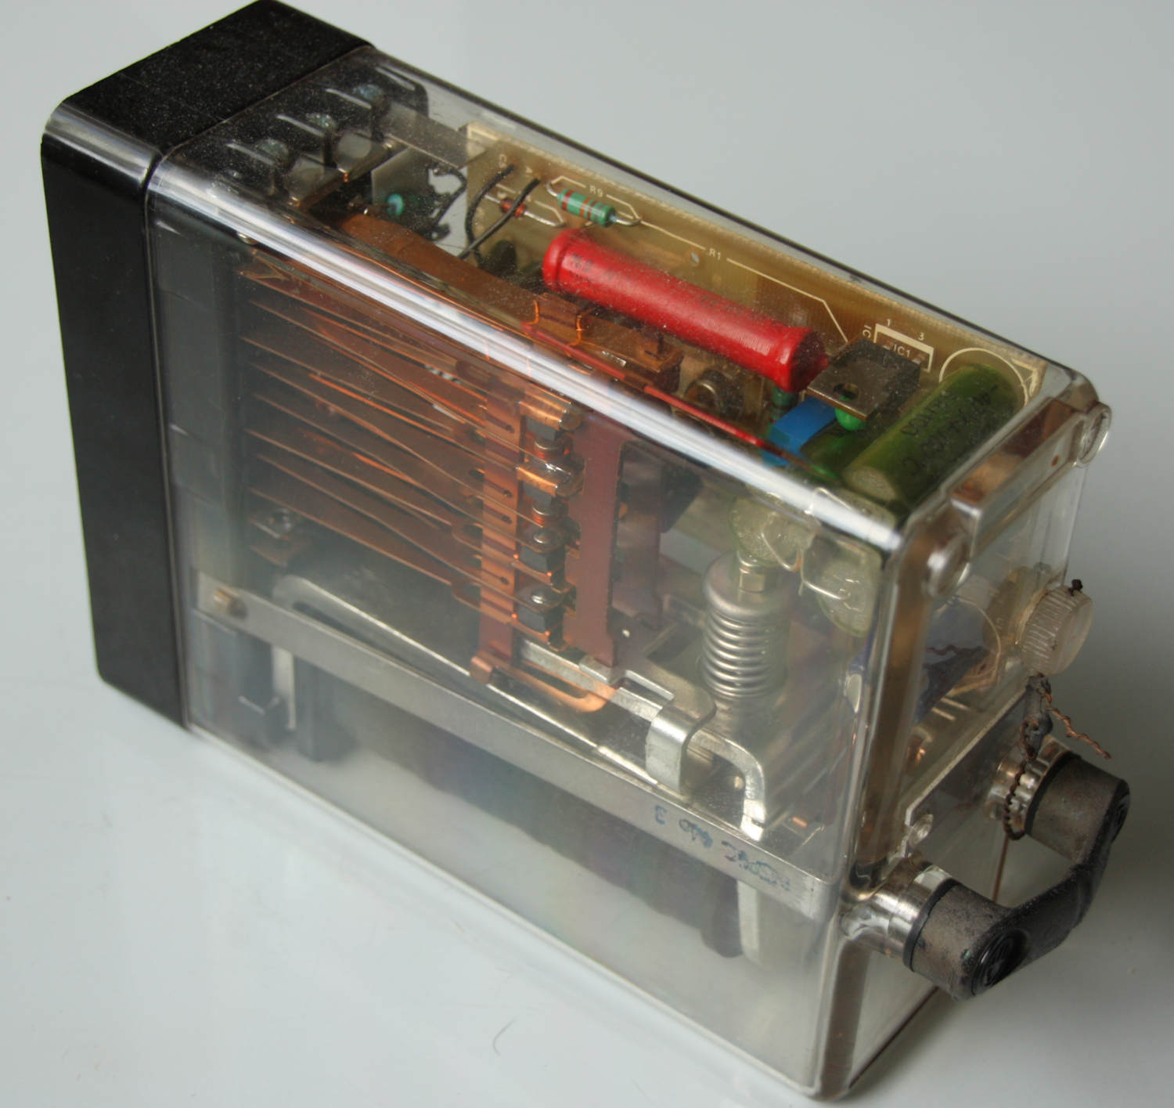It is hard to think of a more defining piece of signalling equipment of the second half of the 20th century than the relay. It is surprising, however, how little attention has been paid to the relay either in the professional or enthusiast literature. Perhaps because this because the relays are hidden away in relay rooms and equipment cupboards. Hopefully, this article will do a little to bring the signalling relay ‘out of the cupboard’.

The BR930 style relay is particularly significant as it was the ultimate development of the traditional signalling relay and was widely used in the UK and Australia. Its development changed the economics of signalling schemes. Had this relay not been developed, the large resignalling schemes of the 1960s and 1970s probably would have been considerably different.

The era of the signalling relay is not yet completely dead – new BR930 relays are still available and installed, but new signalling schemes are now based on computer technology.

This article grew like topsy; it was originally intended to be a couple of photographs with short captions. It grew a little! The author would be very pleased to hear from anyone who has additional information on relay designs, or the use of relays on the Victorian Railways.

1. The information in this paper is largely extracted from the following IRSE papers and the discussions around them:

   Relay Standardisation, JP Coley, IRSE proceedings 1949 pp66-98

   Miniaturisation of Railway Signalling Apparatus, IRSE proceedings 1956 pp209-227

   Modern Designs of Signalling Relays, JP Coley, IRSE proceedings 1960, pp183-212

   BRB Miniature Relays, W Leggett & JE Candler, First presented 6 November 1968, IRSE proceedings 1968-9 p75-114

   The Railway Gazette, 7 September 1951 p266-70 & 14 September 1951 pp291-5
2. There were also three standards for AC relays: single element vane line relays (BS557), two element two position vane track relays (BS520), and two element three position vane relays (BS561). These will not be discussed, as the focus in this paper is the DC relay.
3. CTC was a US innovation developed in the ‘30s. There were no CTC installations in the UK in the ‘50s, and no UK signalling manufacture offered a CTC product.
4. London Transport introduced top plates for AC relays in the mid 1930s. These served a similar function to the plugboards in plug in relays – the permanent wiring was attached to top plates which could be easily placed on top of the relays. The purpose was to allow easy and safe replacement of relays. It is not clear if this development was inspired by plug-in relays, or was an independent development.
5. It appears that the main non-conforming aspect of the Westinghouse large plug-in relays was that they did not have 0BA terminals. Instead, a much more compact arrangement of metal connectors were used, to which up to two wires could be crimped or soldered. To allow the Westinghouse plug-in relays to comply with BS1659, Westinghouse sold a separate adapter – this was simply a vertical board which could be mounted on the racks behind the relay plugboards. This adapter was fitted with 0BA terminals, and the wires from the plugboard connecters were fixed to the terminals. This adapter set the minimum size of the plug-in relay. If the plug-in relay was reduced in size too much, the adapter would not be capable of holding all the 0BA terminals for the relay.
6. John Charles Kubale had a Melbourne connection, and received his initial signalling training on the VR. He was born in Melbourne on 3 March 1903. He served an apprenticeship as an electrical fitter with the S&T Branch of the Victorian Railways commencing on 17 February 1919 and undertook a course at the Melbourne Technical College (now RMIT). He later went to the US and worked at GEC, various US railways, and GRS. After returning to Australia he was appointed as Assistant Engineer on electric traction work in the VR. In 1930, he went to the UK and joined Metropolitan-Vickers-GRS and worked on marshalling yards and railway signalling. He was an expert on automated marshalling yards and designed the hydraulic retarder used in a number of early UK marshalling yards. He served in the Royal Engineers during WWII and rose to the rank of Major. He was awarded an MBE and was mentioned in dispatches. On returning to MV-GRS he was appointed Chief Engineer in October 1945, Manager in 1951, and was subsequently elected to the Board of Directors, retaining this position until he retired in 1981 (the company by this time was AEI-GRS). He died in December 1984.
7. Chandler was speaking at an IRSE meeting in France. Perhaps he felt he could be a bit more open away from the UK. Or, perhaps, lunch had been particularly good!
8. The maximum current specified for the BR930 relays was nominally 3 amps, but the protecting fuses were 5 amps, and so 5 amps was taken as the maximum current for testing welding of the contacts. When the IRSE presented the new relays in France in 1968, it was discovered that the new French relay used metal to metal contacts, but was still used for vital circuits. After discussion, the British signal engineers acknowledged that while 5 amps was the theoretical maximum current, in actual signalling circuits the maximum current did not reach this value due to the resistance in the circuit. Consequently, welding of contacts was acknowledged to be very unlikely.
9. Most of the information in this section is taken from ‘Melbourne Metropolitan Signal Systems Review’, A.A. Carey, IRSE Australia, November 1986.